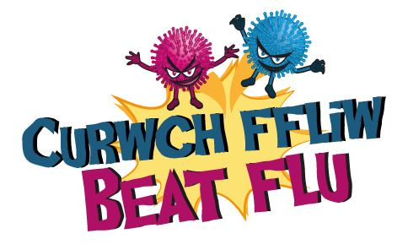
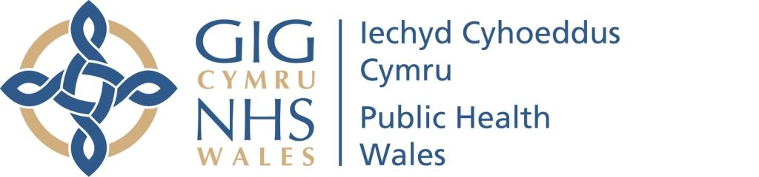

Dear Wales PPA,
Did you know that last winter more than half (54.7%) of children aged 2 and 3 missed out on getting a free influenza (flu) vaccination in Wales?
We want more people to know that flu vaccination is the single best way to protect against catching or spreading influenza.
Often children who get flu can feel very unwell and need a few days in bed, and for some it can cause serious illness. Complications include bronchitis, pneumonia and ear infections. Some children become so unwell, they need to be admitted to hospital.
Children are also ‘superspreaders’ of flu, like other infectious illnesses. Annual flu vaccination not only protects them from catching flu it also reduces the risk of them passing it on.
Children aged 2 and 3 are eligible for a free NHS influenza vaccination, and they can get it from their GP surgery. Because the flu virus can change each year, and the vaccine is changed to get the best match, it’s important they have the vaccination every year they are eligible.
The vaccine for children is a spray- so no needle. Details of the children’s programme can be found at www.beatflu.org.
Beat Flu is a public health campaign in Wales run by Public Health Wales, and aims to raise awareness of the benefits of annual influenza vaccination amongst people who could benefit by being vaccinated.
Please join us in helping raise awareness of the dangers of influenza, and help make sure that parents of children aged 2 and 3 know how serious influenza could be, and that they can help protect their children from influenza with a free vaccination.
There are plenty of ways you can help. This booklet provides some resources for you to use to help raise awareness of the dangers of flu and to help encourage people to have the vaccine. We hope you find them useful.
Thank you in advance for your help and support – we hope that together, we can make a difference and more people will make the right choice and get vaccinated to protect themselves from this potentially serious illness.
The Beat Flu team

Annwyl PPA Cymru,
Wyddech chi, y gaeaf llynedd, fod dros hanner (54.7%) y plant 2 a 3 oed wedi colli’r cyfle i gael brechiad ffliw rhad ac am ddim yng Nghymru?
Rydym am i fwy o bobl wybod mai brechiad ffliw yw’r ffordd unigol orau o ddiogelu rhag dal neu ledu ffliw.
Yn aml, gall plant sy'n cael ffliw deimlo'n sâl iawn ac mae angen ychydig o ddyddiau arnynt yn y gwely, ac ar gyfer rhai gall olygu salwch difrifol. Mae'r cymhlethdodau'n cynnwys broncitis, niwmonia a heintiau clust. Mae rhai plant yn mynd mor sâl fel bod angen iddynt fynd i'r ysbyty.
Mae plant hefyd yn lledaenu ffliw yn hawdd, fel pob salwch heintus arall. Mae brechiad ffliw blynyddol nid yn unig yn eu hamddiffyn rhag dal ffliw, mae hefyd yn lleihau'r perygl y byddant yn ei drosglwyddo i eraill.
Mae plant 2 a 3 oed yn gymwys i gael brechiad ffliw GIG rhad ac am ddim, a gallant ei gael gan eu meddyg teulu. Gan bod y firws ffliw yn gallu newid bob blwyddyn, a bod y brechlyn yn cael ei newid o ganlyniad, mae'n bwysig eu bod yn cael y brechiad bob blwyddyn.
Mae’r brechlyn ar gyfer plant yn chwistrell - sy’n golygu dim nodwydd. Ceir manylion am y rhaglen i blant yn www.curwchffliw.org
Mae Curwch Ffliw yn ymgyrch iechyd cyhoeddus yng Nghymru sy’n cael ei rhedeg gan Iechyd Cyhoeddus Cymru, ac mae’n ceisio codi ymwybyddiaeth o fanteision brechiad ffliw blynyddol ymhlith pobl allai elwa o gael eu brechu.
Ymunwch â ni i helpu codi ymwybyddiaeth o beryglon ffliw, a helpu gofalu fod rhieni plant 2 a 3 oed yn gwybod pa mor ddifrifol allai ffliw fod iddyn nhw, ac y gallant ddiogelu eu plant rhag ffliw trwy gael brechiad rhad ac am ddim.
Gallwch helpu mewn sawl ffordd. Mae’r llyfryn hwn yn darparu rhai adnoddau y gallwch eu defnyddio i helpu codi ymwybyddiaeth o beryglon ffliw ac i helpu annog pobl i gael y brechlyn. Gobeithiwn y byddant yn ddefnyddiol ichi.
Diolch ichi ymlaen llaw am eich cymorth a’ch cefnogaeth – gobeithiwn y gallwn, gyda’n gilydd, wneud gwahaniaeth ac y bydd mwy o bobl yn gwneud y dewis iawn ac yn cael eu brechu i ddiogelu eu hunain rhag y salwch hwn all fod yn un difrifol.
Tîm Curwch Ffliw

