{0><}0{>Hwyl Toes Chwarae!<0}

{0><}77{>Offer: Toes Chwarae,<0} {0><}0{>Cwpan, Powlen a Llwy<0}

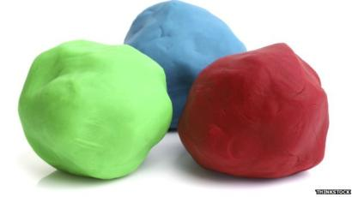
{0><}0{>Mae’n gwneud toes chwarae yn gyflym a hawdd, ac mae’n hwyl. <0} {0><}0{>Mae’r profiad ei hun o wneud hynny gyda’r cynhwysion yn helpu plant arbrofi a dysgu ynghylch symiau a meintiau, mesur a chymysgu. <0} {0><}0{>Gellir cadw toes chwarae mewn cynhwysydd neu fag nag yw aer yn mynd iddo, er mwyn ei ail ddefnyddio. <0}
{0><}0{>Cynhwysion Toes Chwarae:<0} {0><}0{>2 lond cwpan o flawd plaen, ¾ cwpan o halen, 2 lond cwpan o ddŵr cynnes, lliw bwyd a hanfod Fanila (dewisol)<0}

{0><}0{>Sut i wneud toes chwarae:<0}
{0><}0{>• Golchwch eich dwylo’n drwyadl gyda dŵr cynnes a sebon. <0}
• {0><}0{>Mesurwch lond dwy gwpan o flawd plaen a’i dywallt i’r bowlen. <0}
• {0><}76{>Mesurwch ¾ llond cwpan o halen a’i dywallt i’r bowlen. <0}
• {0><}81{>Mesurwch lond dwy gwpan ddŵr cynnes ao’i dywallt i’r bowlen. <0}
{0><}0{>• Gallwch ychwanegu lliw bwyd os dymunwch. <0} {0><}0{>(Dim ond diferyn)<0}
• {0><}0{>Cymysgwch y cyfan gyda’i gilydd. <0} {0><}0{>Daw’n ludiog. <0} {0><}0{>Daliwch i droi nes bod y cyfan o’r gymysgedd wedi dod at ei gilydd. <0}
• {0><}0{>Unwaith y bydd y gymysgedd wedi dod at ei gilydd, defnyddiwch eich dwylo i dylino’r toes. <0}
• {0><}0{>Os yw eich toes chwarae’n rhy ludiog, gallwch ychwanegu chwaneg o flawd. <0}
• {0><}0{>Tyliwch y toes yn lwmpyn llyfn. <0}

{0><}100{>Datblygiad Corfforol<0}

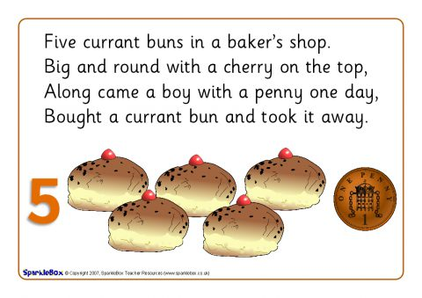
{0><}0{> Wrth durio, rholio a gwasgu toes chwarae, bydd plant yn datblygu’r cyhyrau bychan yn eu bysedd a’u dwylo. <0} ... {0><}0{>Mae nhw hefyd yn cryfhau ac yn dod yn fwy deheuig gyda’u bysedd a’u dwylo, meysydd hanfodol o ddatblygiad corfforol ar gyfer ysgrifennu, tynnu lluniau a phethau eraill. <0} {0><}0{>Mae hefyd yn hwyl i bob oed! <0}
{0><}0{>Manteision eraill toes chwarae yw:<0}
{0><}0{>Mae tylino toes yn tawelu ac mae iaith yn datblygu wrth siarad am y gwead a'r ffurfiau. <0} {0><}0{>Gall y syniadau isod hefyd annog dychymyg eich plentyn. <0} {0><}0{>Neu pam na rowch chi dro ar wneud 5 bynsen gyrens a chanu’r gân. <0} {0><}0{>Gallwch hefyd addasu’r ryseitiau i gynyddu cywreinrwydd a gwybodaeth ynghylch y gwahanol weadau e.e. gallwch ychwanegu eli dwylo i gael gwead gwahanol. <0}

{0><}100{>Gweithgareddau <0}
{0><}0{>Mae’n hwyl chwarae a dysgu gyda thoes chwarae. <0} {0><}0{>Bydd gennych chi eich syniadau gwych eich hunan ac mae yna gymaint o gyfleoedd i'w drawsffurfio'n bob math o bethau. <0}

{0><}0{>Dyma rai syniadau i’ch cael chi i ddechrau:<0}

{0><}0{>Casglwch ychydig o offer sydd o gwmpas y tŷ i helpu eich plentyn i archwilio a gwneud marciau ar y toes chwarae. <0} {0><}0{>Gallech ddefnyddio pin rowlio, torwyr bisgedi, llwyau, caeadau potiau ayb. Mae defnyddio pin rowlio yn helpu plant i ddefndyddio eu hysgwyddau ac yn cryfhau eu breichiau. <0}
{0><}0{>Peli Toes Perffaith:<0}
{0><}0{>Anogwch eich plentyn i greu peli chwarae o does. <0} {0><}0{>Mae rhowlio’r peli’n her arall i blant ddefnyddio eu dwylo gan fod yn rhaid iddyn nhw weithio mewn cyfeiriadau croes a gwneud symudiadau cylch. <0} {0><}0{>Gwnewch beli enfawr, peli bychan a siaradwch gyda’ch gilydd ynghylch eu meintiau. <0}
{0><}0{>Offer a Llestri:<0}
{0><}0{>Efallai fod gennych rai llestri (asesiad risg) y gallai'r plant eu defnyddio gyda'u toes chwarae. <0} {0><}0{>Gallwch ddangos mor wahanol i fforc y mae llwy'n torri'r toes. <0} {0><}0{>Efallai fod gennych chi gyllyll a ffyrc y gall eich plant eu defnyddio i ymarfer eu sgilau helpu ei hunan adeg pryd bwyd. <0} {0><}0{>Dylai’r toes chwarae fod yn braf ac yn feddal ac yn hawdd i blant ei dorri a'i drin (os yw'n glynu gallwch ychwanegu ychydig o flawd). <0} {0><}0{>Gadewch iddyn nhw chwarae gyda’r offer a gweld beth fyddan nhw'n ei greu. <0}
{0><}0{>Patrymau Toes<0}
{0><}0{>Efallai fod gennych chi rai offer neu lestri gyda phatrymau arnyn nhw. <0} {0><}0{>Edrychwch ar waelod cwpan neu efallai goes llwy i weld a oes yna batrwm diddorol arnyn nhw. <0} {0><}0{>Ceisiwch lyfnhau’r toes gyda spatwla. <0} {0><}0{>Mae defnyddio gwahanol stwnshwyr hefyd yn hwyl. <0} {0><}0{>Gall eich plentyn roi tro ar y rhain drwy bwyso’r offer yn erbyn y toes. <0} {0><}0{>Efallai y byddan nhw eisiau creu eu patrymau eu hunain drwy wneud marciau ar y toes. <0}
{0><}0{>Nadroedd Neis<0}
{0><}0{>Gall plant wneud pob math o greadigaethau rhyfeddol gyda thoes chwarae. <0} {0><}0{>Efallai y byddan nhw eisiau gwneud eu neidr neis eu hunain. <0} {0><}0{>Mae hyn yn helpu plant i ddefnyddio eu dwylo, eu symud yn ôl ac ymlaen mewn cyfeiriadau croes. <0} {0><}0{>Fe allan nhw greu nadroedd o wahanol hyd a maint. <0} {0><}0{>Pa un yw’r hiraf?<0} {0><}0{>A fydd yn cyrraedd pen y bwrdd?<0} {0><}0{>Efallai eu bod wedi gwneud neidr fychan, fychan. <0}
{0><}0{>Toes Trysor<0}
{0><}0{>Cuddiwch drysor yn y toes chwarae i’ch plentyn ei ganfod. <0} {0><}0{>Gallwch guddio arian, botymau, mwclis (asesiad risg) yn y toes chwarae. <0} {0><}0{>Mae cloddio am y trysor yn ymarfer gwych i ddwylo a bysedd eich plant. <0} {0><}0{>I annog mân Sgiliau Symud pam na wnewch chi annog eich plentyn i ynysu eu bysedd wrth iddyn nhw arbrofi. <0} {0><}0{>Gallwch ddweud “Beth am gael Modryb y Fawd i bwyso ar y toes!”<0} {0><}0{>Gallwch hefyd gael eich plentyn i binsio’r toes chwarae i weithio ar y gafael pinsiwrn. <0} {0><}0{>Anogwch eich plant i wasgu’r toes chwarae eu ddwylo y gryfhau gafael y llaw. <0} {0><}0{>Ceiswich gael eich plant i ddefnyddio'r bysedd a'r dwylo, mae hynny helpu i ddal peniau a phensiliau wrth ddechrau ysgrifennu'n ddiweddarach. <0}

{0><}100{>Awdur:<0} {0><}0{>TTS Limited Copyright © 2020 TTS Group Ltd<0}

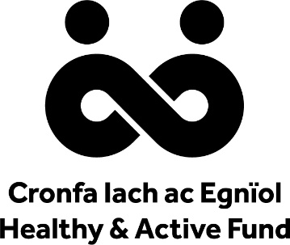

w
Prosiect sy’n cael ei ariannu gan Gronfa Iach ac Egniol, partneriaeth rhwng Llywodraeth Cymru, Chwaraeon Cymru ac Iechyd Cyhoeddus Cymru

